Responsible AI

Artificial intelligence (AI) is defined as the ability of machines to exhibit human-like capabilities such as reasoning, learning, planning and creativity. It comes as software in the form of virtual assistants, image analysis software, search engines, speech and face recognition systems as well embodied as robots, autonomous cars, drones, internet of things etc. This pervades in everyday life providing personalised recommendation for online shopping/advertising, used by search engines, digital personal assistance on smartphones, virtual assistants answering questions, language translation, automated subtitling, smart thermostats for saving energy, regulating traffic, self-driving cars, navigation, automated sensors for car safety, used to identify cyberattacks, used at airport to detect thermal imaging, detect infections and detect fake news just to mention a few (NewsEuropeanParliament, 2021).

Elon Musk founder of Tesla and SpaceX is quoted as saying “AI is far more dangerous than nukes” which corroborates that of Stephen Hawkings who warned that “Unless we learn how to prepare for, and avoid, the potential risk AI could be the worst event in the history of our civilization”. Stuart Armstrong suggest AI poses an extinct risk stating that “If AI went bad and 95 percent of humans were killed, the remaining 5% would soon be extinct soon after”. Early signs of job risk due to automation, malicious use of AI with criminals training machines to hack or social engineer humans, physical security weaponizing drones, security threats with AI powered surveillance, profiling, repression, the use of AI to manipulate voices amongst others and more worrying is the use of AI on privacy and security (Thomas, 2021).

The ‘writing is on the wall’ with an ubiquitous AI landscape where technological advancement and development have seen several algorithms developed for many computer applications that processes high volumes in record time with high human intelligence which leaves a lot of control in the hands of data scientists and programmers who develop them. As expected with this level of control there is no conformity or uniformity in standards for organisations who invest in AI and it comes as no surprise the calls from Microsoft, Google and IBM for responsible AI with a governance framework and charter (Labbe, 2020). They are looking to bring European standards, government bodies and business who invest to create and adopt responsible AI”. Responsible AI is “a governance frame that documents how specific organisations address the challenges around artificial intelligence from both an ethical and legal view” resolving ambiguity for responsibility should something go wrong (Gillis, 2021). To design responsible AI there should be a maturity model for designing and implementation that makes use of shared code repositories, approved model structure, sanctioned variables, establishing bias testing methodologies to determine validity of test, stability standards for machine learning models

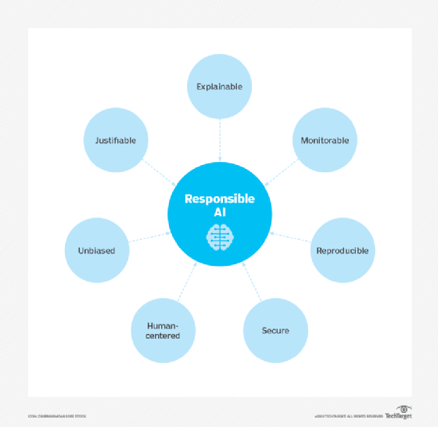

(Gillis, 2021). Google recommends the use of human-centred design approach, identify multiple metrics to assess training and monitoring, examine raw data to understand limitation of datasets and models, testing and continuously monitoring and updating systems after deployment (Google, 2021). Microsoft advocate fairness, reliability & safety, privacy & security, inclusiveness, transparency and accountability with the Office of Responsible AI (ORA), Responsible AI Strategy in Engineering (RAISE) and the AI, Ethics and Effects in Engineering and Research (Aether) Committee to advice and oversee implementation (Micosoft, 2021).

To conclude Musk states that “I am not normally an advocate of regulation and oversight — I think one should generally err on the side of minimizing those things — but this is a case where you have a very serious danger to the public … It needs to be a public body that has insight and then oversight to confirm that everyone is developing AI safely. This is extremely important.”

Gillis, A. S. (2021). *What is Responsible AI? Guidance and Best Practices*. Techtarget. https://searchenterpriseai.techtarget.com/definition/responsible-AI

Google. (2021). *Responsible AI practices – Google AI*. Google. https://ai.google/responsibilities/responsible-ai-practices/

Labbe, E. scannell;Mark. (2020). *IBM’s Policy Lab calls for AI regulation*. Techtarget. https://searchenterpriseai.techtarget.com/news/252478095/IBMs-Policy-Lab-calls-for-AI-regulation

Micosoft. (2021). *Responsible AI principles from Microsoft*. Microsoft. https://www.microsoft.com/en-us/ai/responsible-ai?activetab=pivot1%3Aprimaryr6

NewsEuropeanParliament. (2021). *What is artificial intelligence and how is it used? | News | European Parliament*. News European Parliament. https://www.europarl.europa.eu/news/en/headlines/society/20200827STO85804/what-is-artificial-intelligence-and-how-is-it-used

Thomas, M. (2021). *7 Risks Of Artificial Intelligence You Should Know | Built In*. Builtin.Com. https://builtin.com/artificial-intelligence/risks-of-artificial-intelligence